**Electronics**

Hi! This case will help you practicing before your laboratory mid-term exam (UTP). In this case, you will use all of the knowledge that you have learn from session one to seven. Here are some notes on the function that can help you solve this case:

**\*Notes – try learn this <ctype.h> library’s function\***

*isalnum(), isalpha(), isdigit()*

**\*The function above is optional to use, as long as the program working according to the case you are free to use your own logic 😊\***

Have Fun!

When the program has been run, here’s the program flow that you need to create:

* In the beginning of program’s execution, it will show **four menu options**.
  1. Insert Electronic Stock
  2. Update Electronic
  3. Sell Electronic
  4. Exit

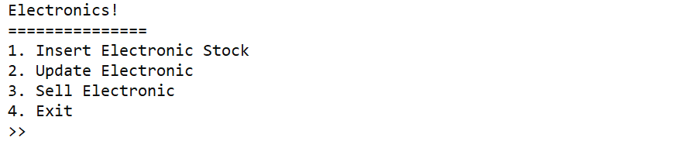

**Figure 1 Main menu**

* If user inputs **Menu 1** (Insert Electronic Stock), do:
  + - **Ask** user to input **Item Id number**, validate that the ID must be **digit (number)** and it must be exactly **3 digits**! After user input the id number, you must generate the ID with the current format:

**ETCYYY**

Where

YYY = the digit from user’s input

* + - Next, **ask** user to input **Item Name**, validate that the name length must be **between 5-25 characters**.
    - Next, **ask** user to input **Item Price**, validate the price must not more than 5000000.
    - After all of the input, Insert the data into **arrays**. And then **show that the insert is success**.

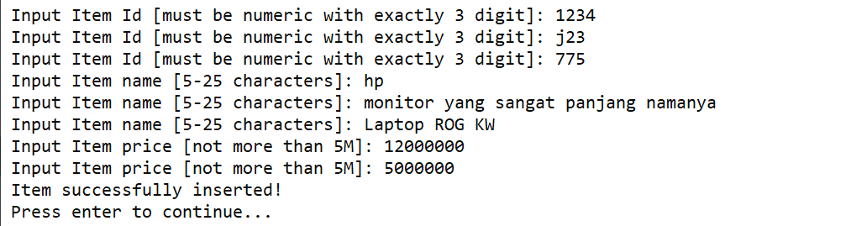

**Figure 2 Insert Menu**

* If user input **Menu 2** (Update Electronic), do:
  + **Print** **list of items** that you have added, validate **if there is no item**, show **no item message.**

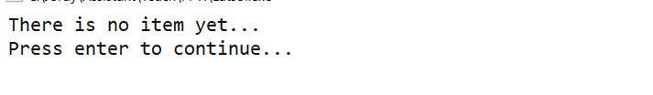

**Figure 3 list of items (when no item)**

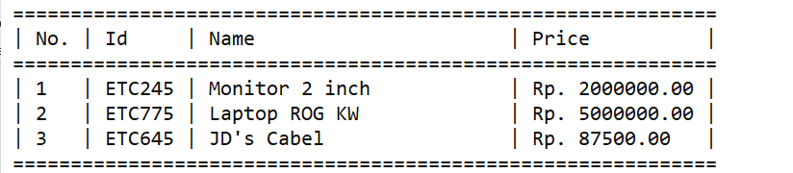

**Figure 4 list of items**

* + **Ask** user to **choose the number** of items it wants to update. Validate that the number must be between **0 to the last item that shown**.

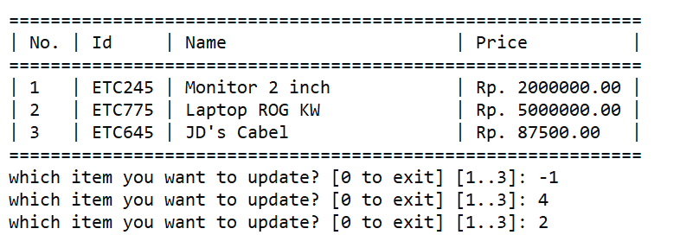

**Figure 5 Input Item to Update**

* + **If** user not **input 0** ask user to do the same input as the **Menu 1**. Then **update** the data and **show success Update Message**.

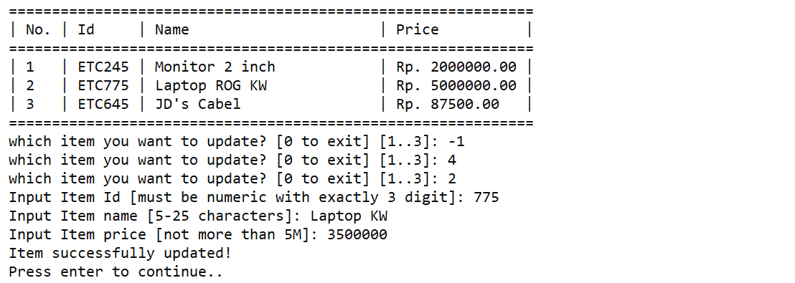

**Figure 6 Update Item**

* If user input **Menu 3** (Sell Electronic):
  + **Print** **list of items** that you have added, validate **if there is no item**, show **no item message.**
  + **Ask** user to **choose the number** of items it wants to update. Validate that the number must be between **0 to the last item that shown**.
  + There is a **30% chance** that you can give a **25% discount** to the item you want to sell. **If** user not **input 0**, calculate the **total price** and **show the item details**. You must **show a message** if the customer is lucky and got a discount!

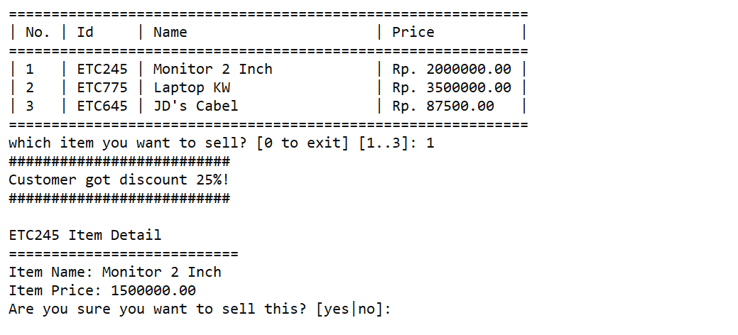

**Figure 7 Sell Item (with discount)**

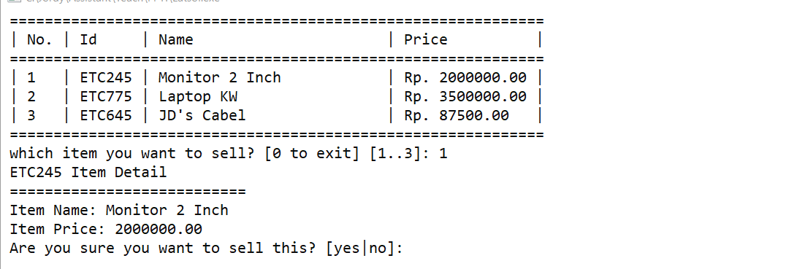

**Figure 7 Sell Item (without discount)**

* + Then, **confirm user** is it really want to sell the item or not. Validate user must input neither “**yes”** or **“no”** *(Case Sensitive)*. If user input “**no”**, show **cancel selling message** and then return **to main menu** *(Case Sensitive)*. If user input “**yes**”, show **success message** and **delete** the item from the arrays *(Case Sensitive)*.

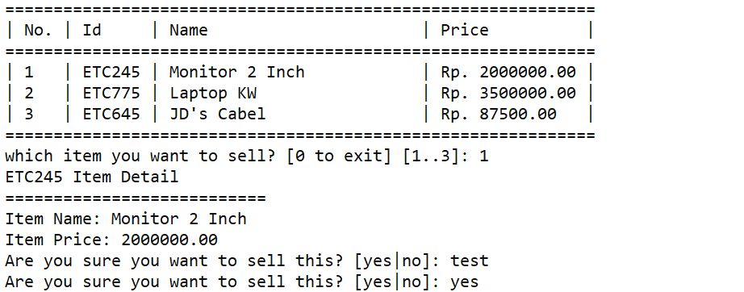

**Figure 8 Sell confirmation**

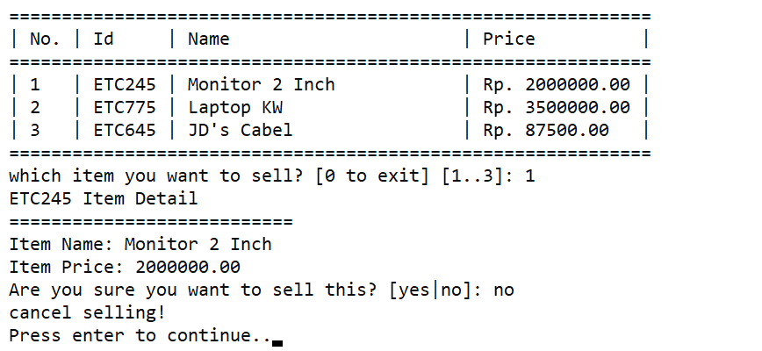

**Figure 9 Cancel Sell**

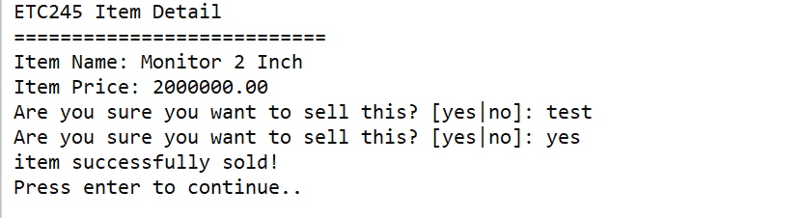

**Figure 10 Success Sell**

* If user input **Menu 4** (Exit), system will be closed.